Chapter 19, Solution 87

(a) Since a = and c = ,

we open-circuit the input port and let V₂ = 1 V. The schematic is shown below. In the AC Sweep box, set Total Pts = 1, Start Freq = 0.1592, and End Freq = 0.1592. After simulation, we obtain an output file which includes

FREQ IM(V_PRINT2) IP(V_PRINT2)
1.592 E–01 5.000 E–01 1.800 E+02

FREQ VM($N_0001) VP($N_0001)
1.592 E–01 5.664 E–04 8.997 E+01

From this,
a =

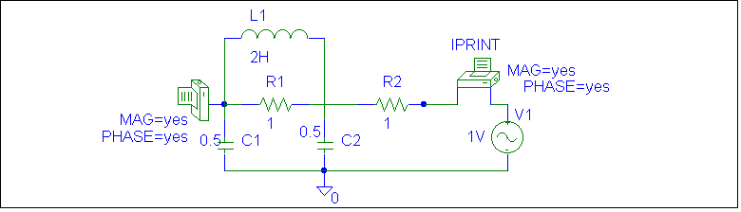
c =

(b) Similarly,
b = and d =

We short-circuit the input port and let V₂ = 1 V. The schematic is shown below. After simulation, we obtain an output file which includes

FREQ IM(V_PRINT2) IP(V_PRINT2)
1.592 E–01 5.000 E–01 1.800 E+02

FREQ IM(V_PRINT3) IP(V_PRINT3)
1.592 E–01 5.664 E–04 –9.010 E+01

From this, we get
b = = –j1765

d = = j888.28

Thus [t] =

